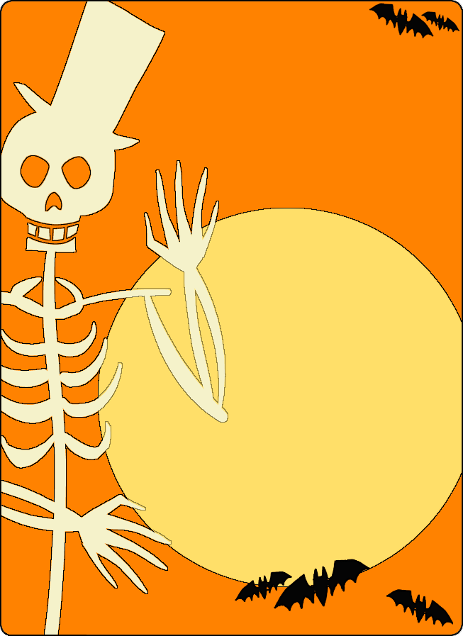
Halloween Event

October 18th at 7:00pm

Rolling Hills Amenity Center
Please join us for a Halloween egg hunt.
Light snacks and beverages will be provided
Halloween Costume Contest
RSVP: Freddie Oca at Rhmanager@Riversidemgtsvc.com

